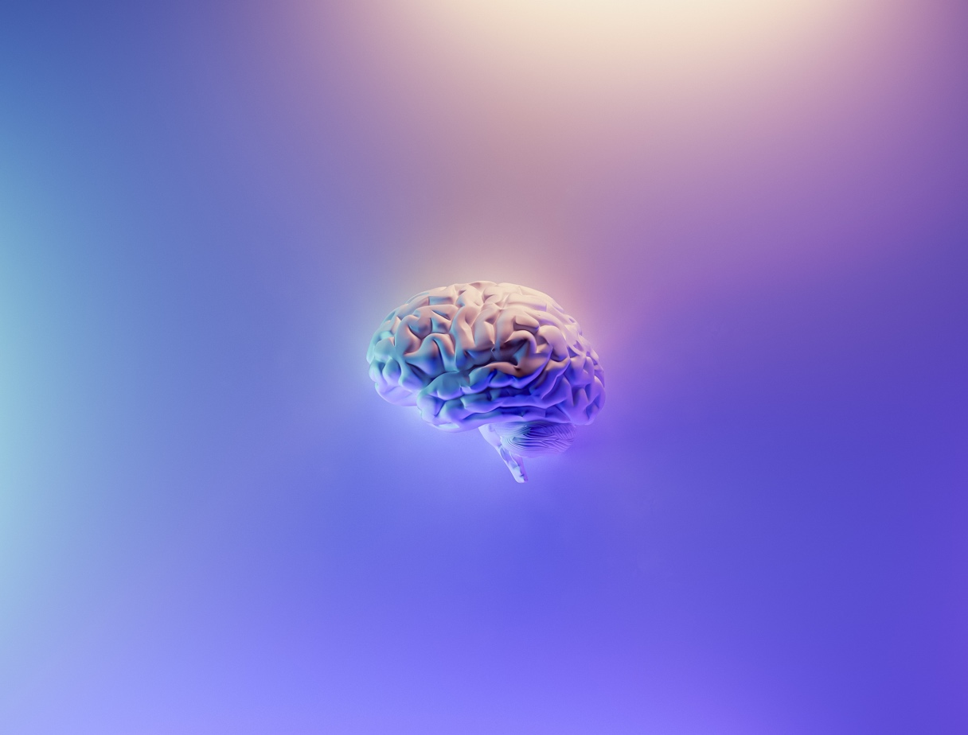

The ABCs of CST or
Craniosacral Therapy: What is it
(spoiler alert—it’s not massage) and Who Might it Help?

Craniosacral Therapy is a therapeutic technique in which the therapist uses the bones of the skull and the sacrum (the bone at the base of the spine) as boney handles to palpate and assess the craniosacral rhythm, to identify adhesions and restrictions and, through gentle manipulation of tissue and direction of energy, to initiate the body’s natural ability to heal itself. It improves the flow of cerebrospinal fluid as well as its rhythm, thereby bathing the membranes which surround, support and cushion the brain and spinal cord in nourishing and protective fluid. This gentle work also improves the mobility of the cranial sutures to move with the flow of cerebrospinal fluid, enhancing its flow. The therapist is called on to assist the body to heal itself rather than force a system or tissue response. This can be a challenge for those whose egos or strong belief in the infallibility of western medicine—or our current understanding thereof--demand that we as therapists be the “healer” rather than facilitate the body’s innate ability to heal itself.

The craniosacral system is a semi-closed hydraulic system contained within a tough waterproof membrane (the Duramater) which envelops the brain and spinal cord. This system produces, circulates and reabsorbs cerebrospinal fluid. Cerebrospinal fluid is important because it maintains the physiological environment in which the brain and nervous system develop and function.

The production and reabsorption of cerebrospinal fluid produces a continuous rise and fall of fluid pressure within the craniosacral system. The system expands and contracts as the cerebrospinal fluid moves throughout the system. This rhythmic expansion and contraction prevents pressure from building up too much within the craniosacral system. It is this rhythm or pulse that the therapist palpates and assesses.

The craniosacral rhythm can be felt throughout the body. It is slower and more subtle than either the cardiac or respiratory rhythms. Palpation of the rhythm is used to monitor where the craniosacral system is operating normally or abnormally. If pressure builds up within the craniosacral system, it contributes to dysfunction and ill-health, especially in the central nervous system which is encased within the craniosacral system. It is through gentle manipulation of tissue and direction of energy to these adhesions and dysfunctions that the therapist facilitates the healing cascade within the body. And as my Kinesiology teacher said, “Magic happens.”

According to the Upledger Institute, “Few body structures have more influence over your health and well-being than your central nervous system. And few body systems have more impact on your central nervous system than the craniosacral system—the soft tissues and fluid that protect your brain and spinal cord…. Craniosacral Therapy reduces tensions to allow the entire body to relax and self-correct. Using a gentle touch, starting with about the weight of a nickel, practitioners evaluate you for strain patterns. Then they use distinctive light-touch techniques to release any restrictions they find. …. Craniosacral Therapy has been shown to naturally reduce pain and stress, strengthen your resistance to disease and enhance your health and well-being.”

Craniosacral Therapy has been shown to help a full spectrum of pain and dysfunction, including:

- Migraines and Headaches
- Chronic Neck and Back Pain
- Stress and Tension Related Disorders
- Motor-Coordination Impairments
- Spinal Cord Injuries
- Post-Concussion Symptoms
- Chronic Fatigue
- Fibromyalgia
- TMJ Syndrome
- Scoliosis
- Post-Traumatic Stress Disorder

What you experience from a Craniosacral Therapy session is as unique as you are. The sessions take place in a quiet, private setting. You remain fully clothed in comfortable soft clothing such as soft sweat pants or yoga pants and a light weight shirt. You relax on a comfortable, padded massage table, often covered by a light blanket. The session can last an hour or more. It can be used alone or integrated with other therapies to facilitate powerful changes.

If you are interested in receiving a craniosacral therapy session, Soul Ease Medical Massage has you covered. You can book a 60 minute, 90 minute or 120 minute CST session and experience this deeply healing work for yourself.

